Information for the platform related to Drought Impact Reporting Network

|  |  |
| --- | --- |
| **Deliverable Title:** |  |
| **Deliverable Leader** | Monika Bláhová |
| **Contributing Author(s)** |  |
| **Dissemination Level:** | Public |
| **Due Date:** | 15/03/2023 |

Table of contents

1. Czech and global drought monitoring platform - introduction 2

2. Czech National Reporting Network 5

3. International reporting website 6

4. Frequently asked questions 9

4.1 How can we start? 9

4.2 Why do we need reporters? 9

4.3 How many reporters should we aim for? 9

4.4 Why do we have three types of questionnaires (agriculture, forestry, fruit growing)? 9

4.5 Where should the observation be done? Where should reporters observe the impacts? 9

4.6 How much time does it take to fill in the questionnaire? 9

4.7 How to communicate with reporters? 10

5 References 11

6 List of acronyms 11

# Czech and global drought monitoring platform - introduction

Czech Drought Monitor [1], available at [www.intersucho.cz](http://www.intersucho.cz) (CzechDM), provides comprehensive sold drought monitoring and prediction tool to map drought and consequent impacts in Czechia, Slovakia, Central Europe, and also on a global level.

The system is leaning on a combination of 3 base monitoring methods, including modeled soil moisture content (SoilClim model [2,3]), remote sensing data, and a network of voluntary expert agriculture reporters providing regular information about soil water content and observed drought impacts on crops.

SoilClim model provides daily outputs of Relative Soil Moisture Content (Fig. 1), from which is then derived Drought Intensity (Fig. 2) layer (percentile deviation of current soil moisture content from 1961 to 2010 reference period) and Soil Moisture Content Anomaly (Fig. 3) in mm (as a deviation from 1961-2010 period). Layers produced by the SoilClim model seamlessly cover the areas of Czechia and Slovakia in 500 m spatial resolution in 3 soil depths 0-40 cm, 40-100 cm, and 0-100 cm.

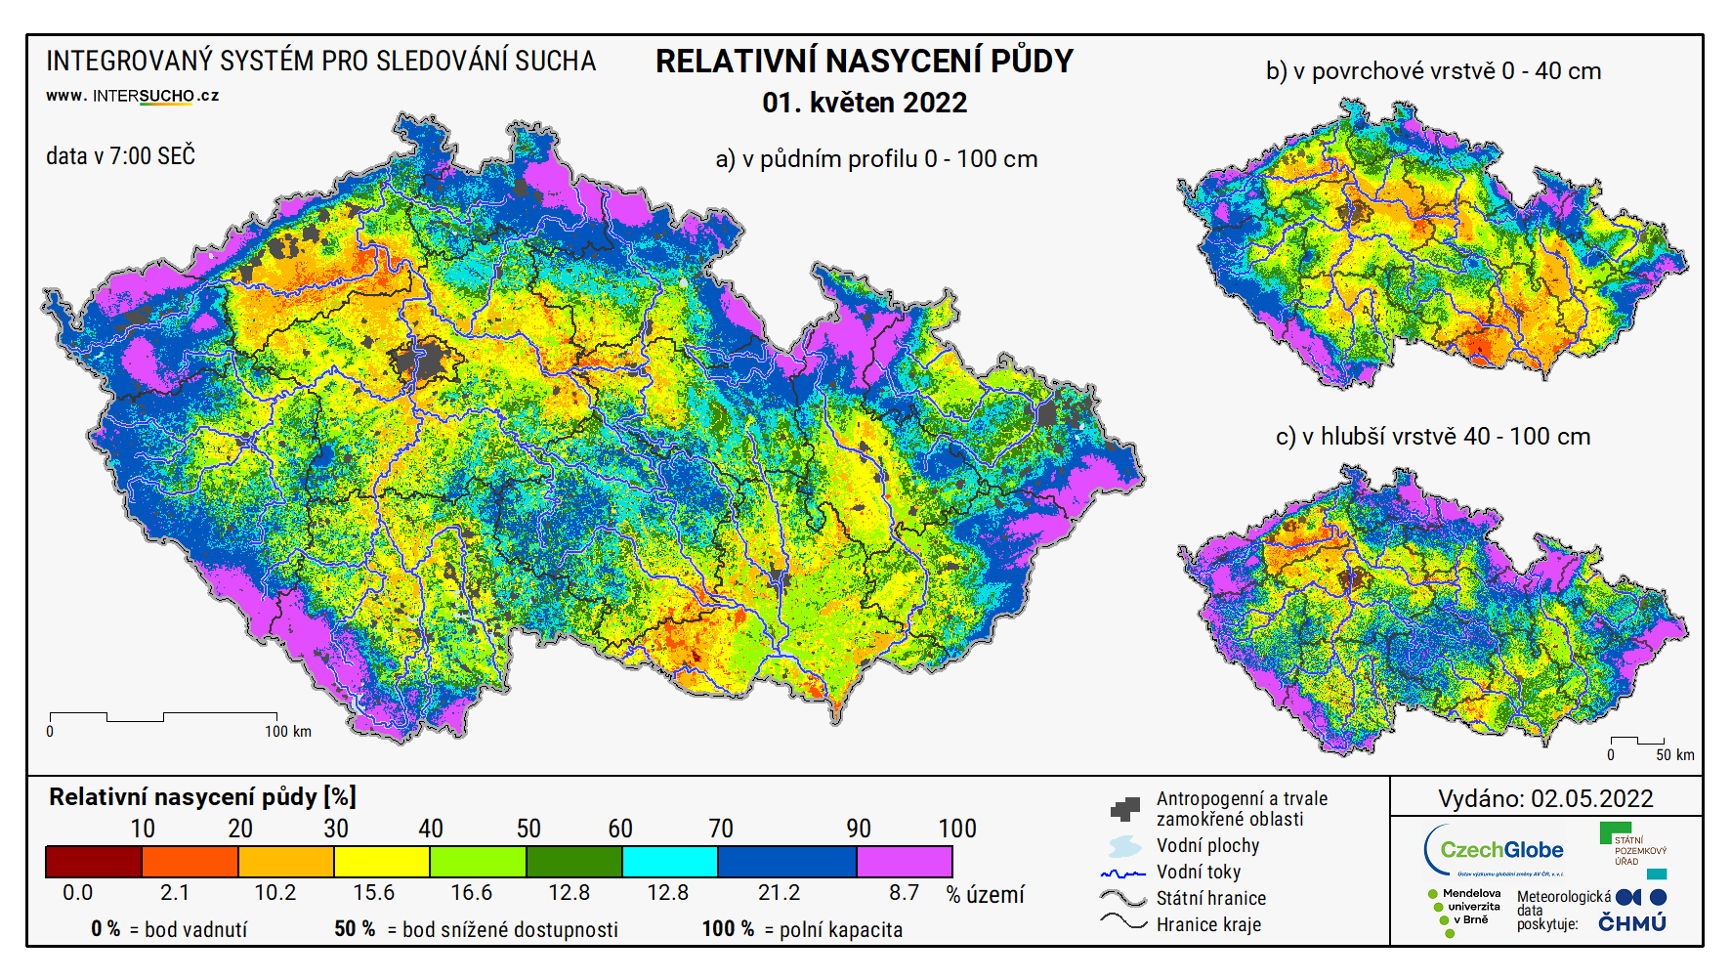

Fig. 1: Relative soil moisture content in Czechia as for 1.5.2022

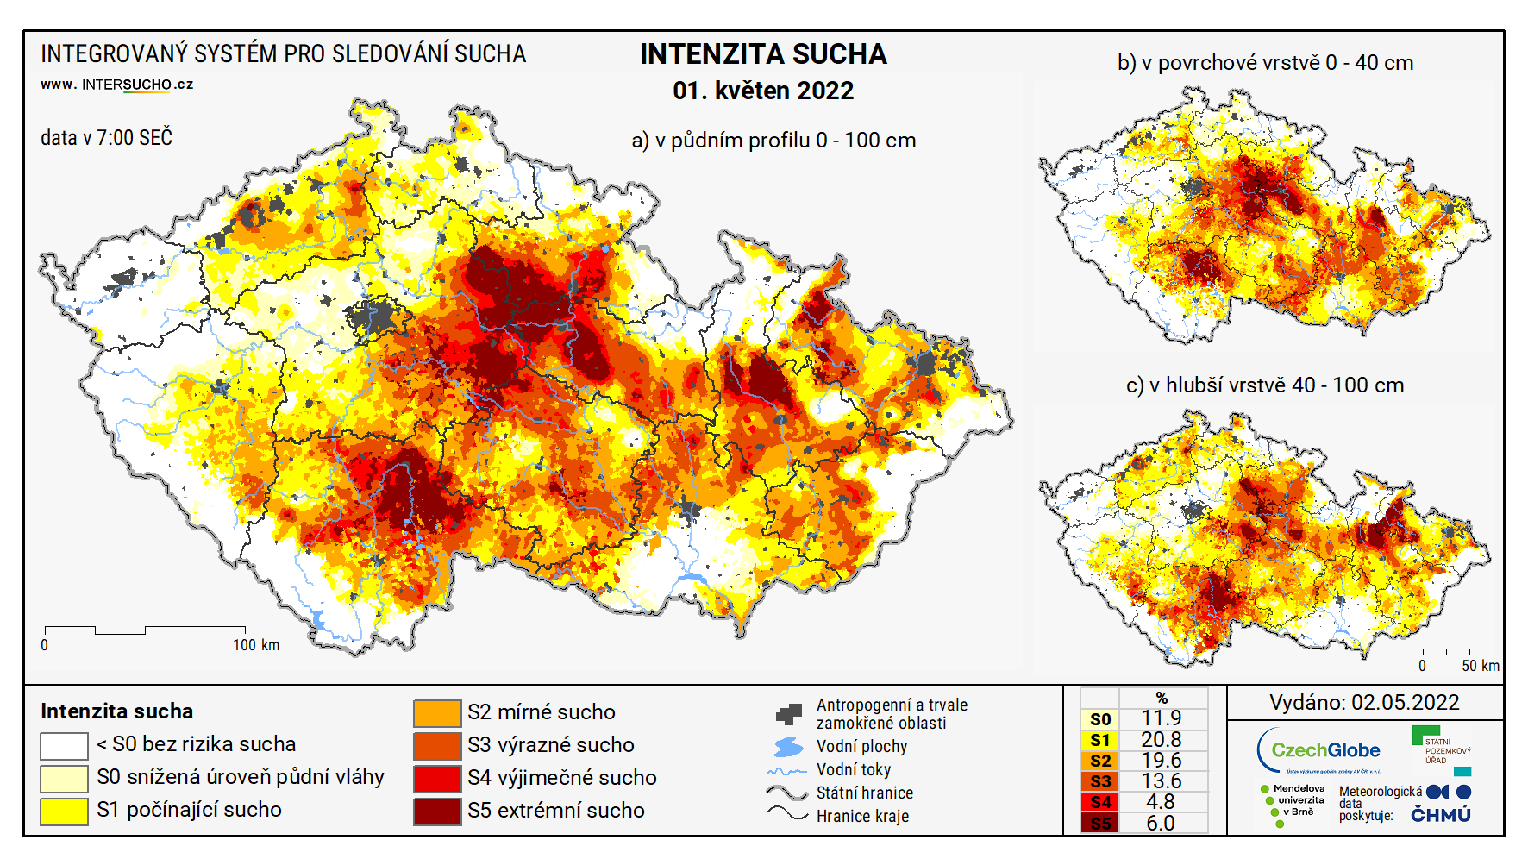

Fig. 2: Drought intensity in Czechia as for 1.5.2022

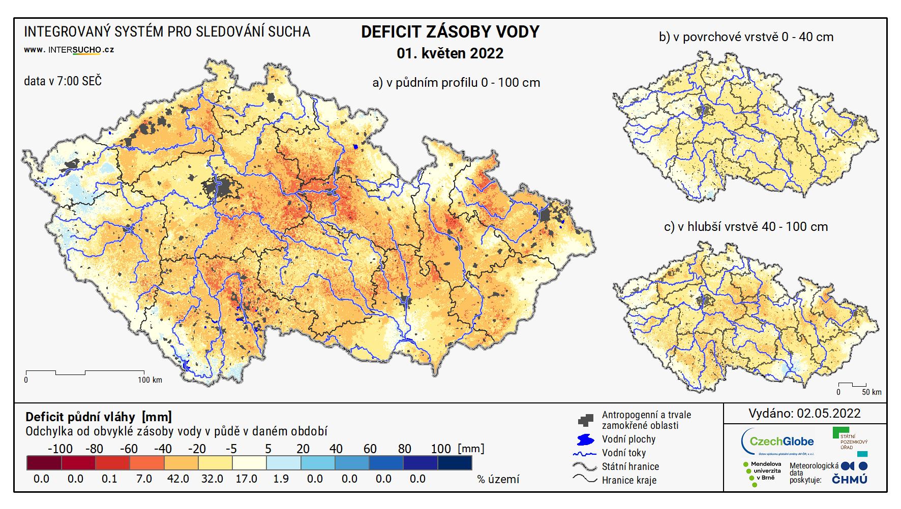

Fig. 3: Soil moisture anomaly in Czechia as for 1.5.2022

Besides monitoring, CzechDM also includes drought prediction component. Prediction of soil drought and basic meteorological parameters is published daily, with a forecasted period of 9 days (Fig. 4).

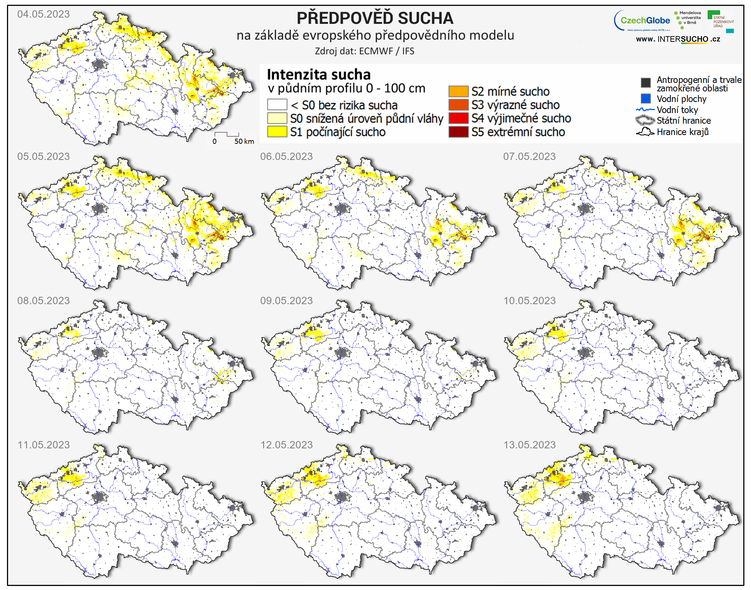

Fig. 4: Example of soil drought anomaly prediction for 9 days as for 5.5.2023.

CzechDM includes various remote sensing products to supplement modeled soil moisture outputs and provide information about other drought parameters and impacts, for example, the state of vegetation or evaporative demands. To complement the soil moisture content information, we include Soil Water Index (SWI), vegetation condition anomaly derived from enhanced vegetation index (EVI2), and Evaporative Stress Index (ESI). All of the remote sensing products vary in the data source as well as spatial resolution. Still, we can produce final outputs on the European level thanks to system coverages (Fig. 5).

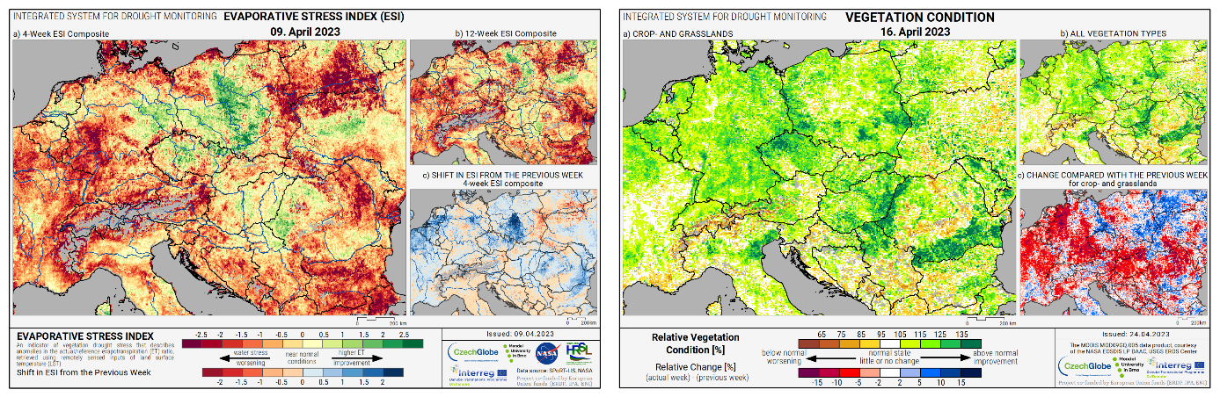

Fig. 5: Example of remoter sensing g component of the CzechDM, ESI on the left, vegetation condition anomaly on the right

The third part of the system is based on a voluntary network of reporters (national reporting network – NRN), delivering weekly reports on soil drought conditions and observed drought impacts on managed crops. Information is provided from a single cadastral area (ca 600 ha on average) and usually comes from the level of a specific farm. Reports are delivered weekly through an online questionnaire available directly on the CzechDM website. Thanks to the nationwide reporting network, we can retrieve near real-time information on drought and impacts from more than 300 reporters per week for Czechia and 150 reporters from Slovakia, covering over 2000 cadastral units.

# Czech National Reporting Network

Soil drought and drought impact reporting is based on a system running in Czechia since 2015. Due to the multi-year drought event in Czechia, the base of the observer system was developed in cooperation with the Agriculture Union of the Czech Republic. The first 25 reporters were nominated from the most drought-impacted regions. Reporting system underwent huge development since 2015, resulting in an online system of 4 questionnaires focused on 4 major impacted sectors in Czechia. All of the questionnaires include a set of easy-to-answer questions focusing on evaluating drought and its impact by sight and based on the reporter’s local knowledge of the reported locality.

Reports are sent weekly on a regular and voluntary basis. Reporters choose one of the Agriculture, Fruit & Grape Vine, Forestry, or Seedlings questionnaires. Each questionnaire contains 3 common questions on soil moisture conditions:

1. Current soil moisture content in topsoil
2. Change of soil moisture compared to the last week
3. Soil moisture conditions in this year’s vegetation season

All of the questions use simple scales to describe soil moisture (soil is dusty X soil is muddy and fully saturated), and we ask reporters to evaluate it by sight - no need to install soil moisture measurements.

The following questions evaluate drought impact on crops and expected yield loss caused by drought. Evaluated crops differ according to the selected questionnaire type, and reporters are focused only on selected crops based on their choice. For agriculture, evaluated crops are:

* Winter wheat
* Spring barley
* Oat
* Spring wheat
* Winter rye
* Oil seed rape
* Sugar beet
* Potatoes
* Sunflower
* Corn maize
* Sileage maize
* Hops
* Poppy
* Alfalfa
* Other clover
* Permanent grassland

The questionnaire covers all commonly grown fruit trees (apples, pears, plums, cherries, grape wine, etc.) for fruit and grape wine evaluation. Forestry and seedling impacts are evaluated by the age of the forest/seedling and the type of habitat.

Thanks to the regular reports and good reporter objectivity [4], reporting network was used as a key parameter to assess the drought compensation claims in Czechia in 2018 and 2019. The system of volunteer reporters was validated with modeled yield losses as well as other drought indices and was proven as a valid drought-induced yield loss reporting mechanism. Thanks to this development w were able to see a growth and stabilization of reporting network (Fig. 6).

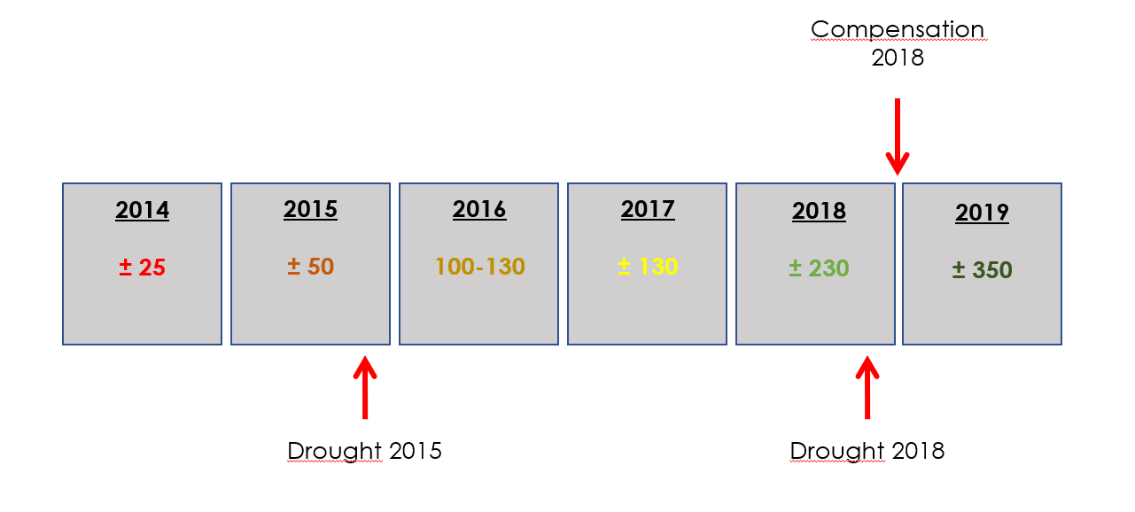

Fig. 6: Number of active reporters in the years 2014-2019

# International reporting website

Based on the working example in Czechia, designed to monitor agricultural drought impacts with a focus on crop yield losses and drought impacts in agriculture-connected sectors such as forestry, fruit growing, or viticulture. The questionnaire is available in 10 languages (available at <http://questionnaire.intersucho.cz/>, Fig. 7), with an easy option to add new translations. After adding translations in any other language, a questionnaire administration page is created to store and analyze all reported data. This administration part is accessible to the selected country representative (national NRN coordinator) to manage data and be up to date on reporter’s information.

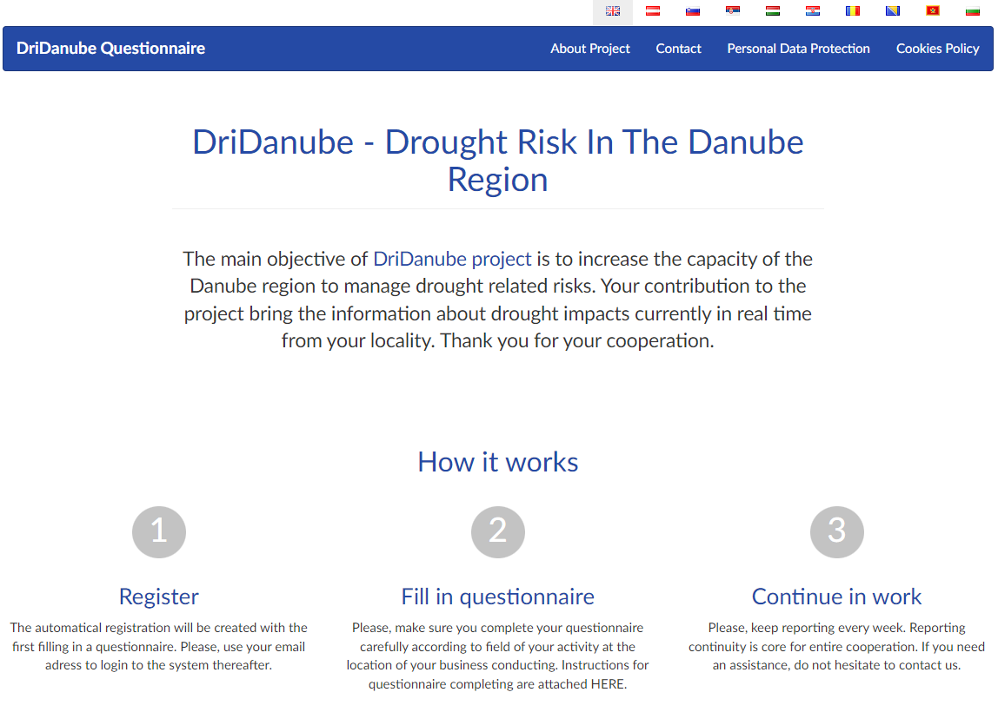

Fig. 7: Homepage of international drought impact questionnaire

Reporters are asked to create an account at the first questionnaire visit (Fig. 8). This includes selecting reporting locality, questionnaire type (Agriculture, Forestry or Fruit Growing), and basic information input as email and name. This information is collected to be able to get in touch with your reporters through NRN.

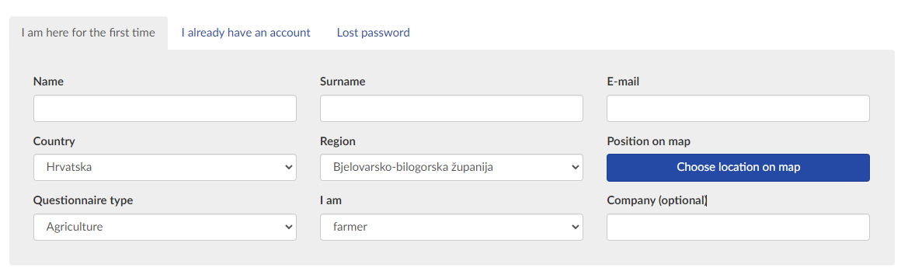

Fig. 8: Mandatory questionnaire header to be filled by reporters once to create user account

After filling the header part of the questionnaire, same structure as in the Czech questionnaire follows, including soil moisture examination (Fig. 9) and observed drought impact on crops (Fig. 10). After sending the first questionnaire in, the reporter is automatically registered, has all the details stored under their account, accessible. The questionnaire stores data input from the last reporting period and the entire history of sent reports.

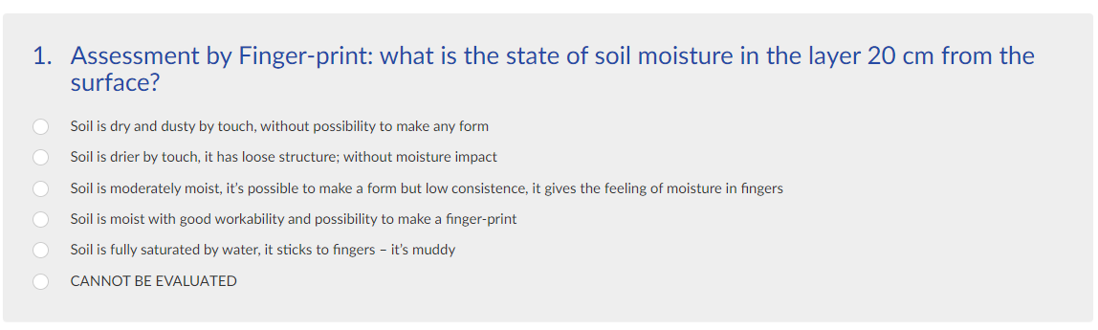

Fig.9: Example of soil drought evaluation question

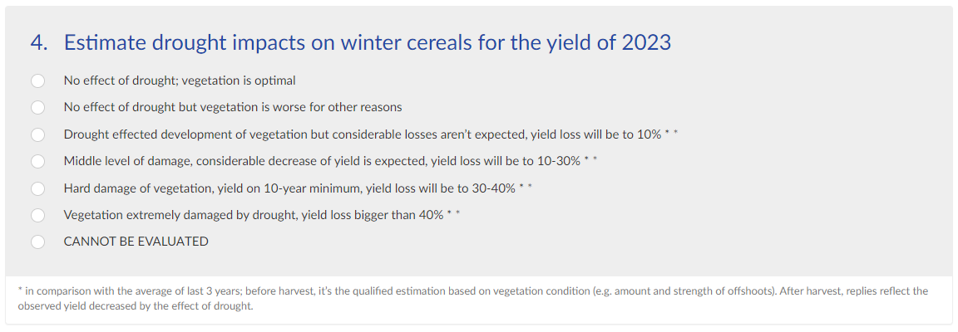

Fig. 10: Example of drought impact on expected yield question

Data are collected in weekly time steps to produce regular maps of reported drought impacts in each active country (Fig.11). Map contains aggregated information on drought impact per country administrative regions and soil moisture content reports from single reporters.

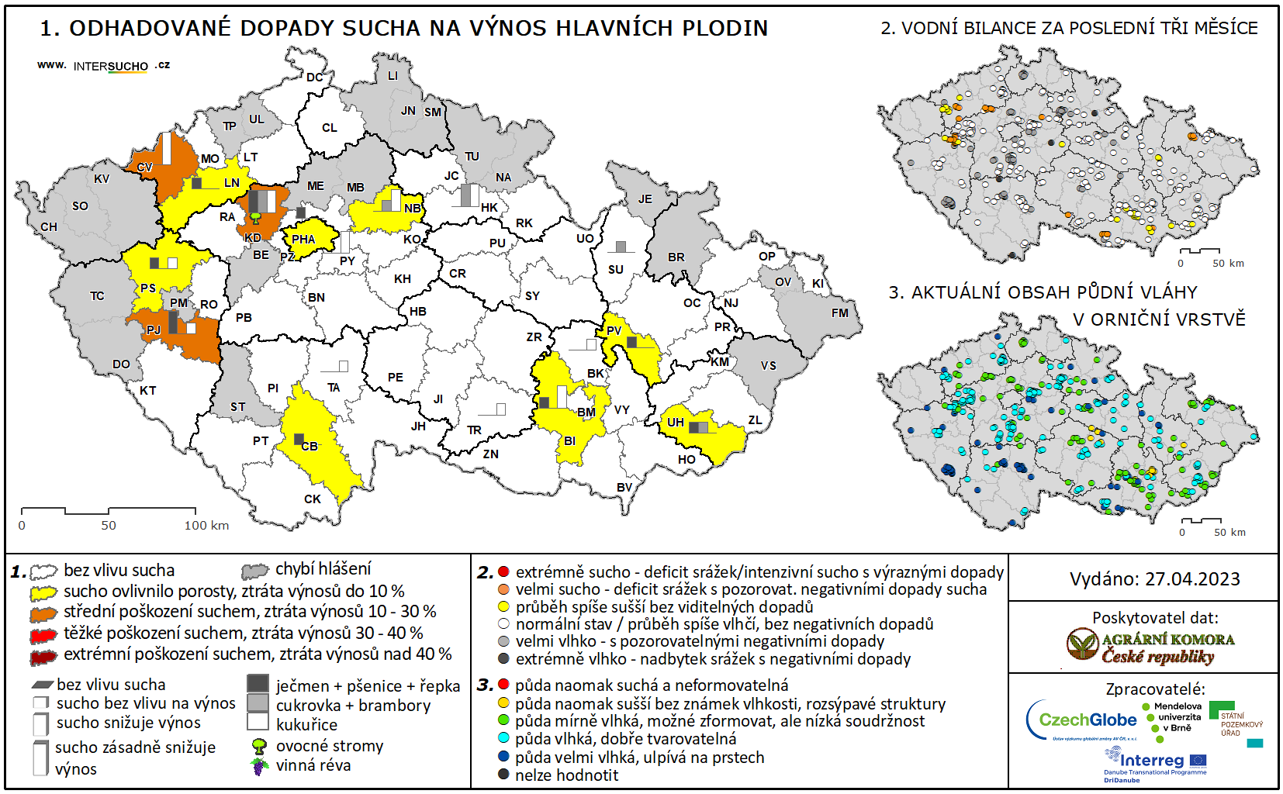

Fig. 11: Reported drought impacts and soil moisture content in Czechia as for 27.4.2023

# Frequently asked questions

### 4.1 How can we start?

Try to prepare and think about where you can find the reporters (farmers, foresters, meteorologists, climatologists, or people who work in nature protection). It is best to contact the leaders or heads of, e.g. agriculture union or agriculture office (or head of departments of the Ministry of Agriculture) in given districts and communicate this topic with them. Ask them for help and discuss with them the possible number of reporters. It is better to start the negotiation in districts where the drought has been a serious problem for a long time, and people want to be involved in work on this topic.

### 4.2 Why do we need reporters?

To bring actual and genuine information about drought impacts (not only about drought occurrence). Up-to-date information with reasonably evaluated drought impacts in agriculture can be obtained only by an expert from practice. News from reporters can subsequently help us to negotiate and show how severe the drought problem is. Results from questionnaires by reporters are processed within two-three days, together with the publication of the drought impact map.

### 4.3 How many reporters should we aim for?

Ideally, you should have 2-3 reporters for suggested national-level regions. Always consider the real number for your country and even realistic reporters number for each impacted sector and consequently for questionnaire type.

### 4.4 Why do we have three types of questionnaires (agriculture, forestry, fruit growing)?

Reported impacts, impact severity, and how the impacts manifest themselves are very different throughout impacted sectors. We want to ensure reporters can cover their field of expertise and give the most accurate impact feedback.

Secondly, we are trying to cover as much of the national impacts as possible, and we are trying to aim at nation-specific needs. From the existing example from Czechia, the most significant droughts are soil drought events, having a substantial potential impact on annual crop production and yields. Therefore, 90% of Czech NRN reporters report using agriculture-focused questionnaires. In Slovakia, the situation is very different, and the focus is mainly on forestry, and most reporters choose the specialized forestry questionnaire. Feel free to balance your reporting network to fit the possible network core and mirror national needs.

### 4.5 Where should the observation be done? Where should reporters observe the impacts?

The reporter should define one locality for which the observation will be done continuously. He/she can change the location within his/her region, but we recommend not changing the place and always bringing the information for the same location. Our advice for reporters is to try to define the place for reporting where the drought impacts are long-term and where you can see that the situation is really bad (thanks to the drought). It is also good to choose a place where the drought impacts are visible well, and the reporter visits this place routinely (farm, orchard, pasture).

### 4.6 How much time does it take to fill in the questionnaire?

The questionnaire should be filled in every week to describe the impacts of drought precisely. Continuity and periodicity of filling out questionnaires are quite important. Finally, it will take 5-10 minutes. Reporters will visit the website where will be a questionnaire in their national language; they will see their reactions from the last week so it can take 1 minute if the situation has not changed from last week.

• It takes only 5-10 minutes to fill in the questionnaire

• Differences each week

• Questionnaire keep the last answers – no need to fill in if there is no change

• Reporters always evaluate the last week (from Sunday to Sunday).

The questionnaires are filled in during the whole year. Since 2015 we cooperate with reporters during the whole year, and we highly recommend this periodicity – the situation in winter can influence spring or summer drought significantly. Try to encourage your reporters to continue monitoring during the whole year.

### 4.7 How to communicate with reporters?

Communication by emails

* The first email – automatically send (username and password for registration)
* The second email – should be more personal, with specific information, long enough to give robust and comprehensive information, with contact on one or two persons from your team who will be taking care of your NRN
* Every week one short email – a reminder to fill in the questionnaire – a really simple, short email with links to the questionnaire. Sometimes we send them actual information, what is new, etc. But we try to keep the email as short as possible.

Personal and collective meetings/visits

* A personal meeting with the most active reporters – if possible we HIGHLY RECOMMEND
* Meetings with given reporters who ask for it - if possible we HIGHLY RECOMMEND
* Collective meetings – if possible we HIGHLY RECOMMEND

We recommend you have one „leader“ for your reporters within your group who will communicate with your reporters and prepare the evaluated questionnaires as an output for preparing the final map. Since the cooperation between reporters and your team will be settled, the leader´s work should take only c. 2 hours weekly.

# 5 References

[1] Trnka, M, Hlavinka, P, Možný, M, et al. Czech Drought Monitor System for monitoring and forecasting agricultural drought and drought impacts. Int J Climatol. 2020; 40: 5941– 5958. https://doi.org/10.1002/joc.6557

[2] Hlavinka, P, Trnka, M, Balek, J, et al. Development and evaluation of the SoilClim model for water balance and soil climate estimates. Ag. W. M. 2011; 98: 1249-1261. https://doi.org/10.1016/j.agwat.2011.03.011

[3] Řehoř J, Brázdil R, Trnka M, Fischer M, Balek J, Štěpánek P, Zahradníček P, Semerádová D, Bláhová M. Effects of Climatic and Soil Data on Soil Drought Monitoring Based on Different Modelling Schemes. Atmosphere. 2021; 12(7):913. https://doi.org/10.3390/atmos12070913

[4] Bartošová, L, Fischer, M, Balek, J, et al. Validity and reliability of drought reporters in estimating soil water content and drought impacts in central Europe. Ag. F. Met. 2022; 315: 108808. https://doi.org/10.1016/j.agrformet.2022.108808

# 6 List of acronyms

CzechDM – Czech Drought Monitor

NRN – National Reporting Network

ESI – Evaporative Stress Index

EVI2 – Enhanced Vegetation Index

SWI – Soil Water Index